CHECK OUT SAN JOSE, CA

San Jose is a hub of Silicon Valley and a cornerstone of the Bay Area. Whether you're booking flights to San Jose, CA for business or pleasure, there are plenty of unique attractions.

(MARKET IMAGE HERE)

Find Deals From These Cities

INSERT FARE GRID FROM / TO Version (if available!)

   
Top Things To Do in San Jose, CA

Here’s just a sampling of what to see in San Jose. Check some (or all) of them out, and have fun!

* Head to Santana Row for some great eateries, chic shops and some fun people-watching. This area is also a hot spot at night.
* Spend an afternoon wandering historic Japantown San Jose. One of only three remaining Japantowns in the U.S., it features authentic restaurants, cultural festivals and art galleries.
* Hang out at San Pedro Square Market in downtown San Jose, where you’ll find many unique vendors selling everything from ethnic foods to home décor items. You’ll love the community vibe here, whether hanging out in the open-air plaza or in one of the fabulous interior spaces.
* One of the top things to do in the Bay Area for aspiring inventors is a visit to The Tech Museum of Innovation.
* Stroll the beautiful San Jose State University campus, and be sure to spend some time admiring the Dr. Martin Luther King, Jr. Library.

Travel Tips and Resources

[Must-Dos in San Jose, CAhttp://www.tripadvisor.com/Attractions-g33020-Activities-San_Jose_California.html](http://www.tripadvisor.com/Attractions-g33020-Activities-San_Jose_California.html)

[San Jose, CA Hotelshttp://www.tripadvisor.com/Hotels-g33020-San_Jose_California-Hotels.html](http://www.tripadvisor.com/Hotels-g33020-San_Jose_California-Hotels.html)

[San Jose, CA Restaurantshttp://www.tripadvisor.com/Restaurants-g33020-San_Jose_California.html](http://www.tripadvisor.com/Restaurants-g33020-San_Jose_California.html)

[San Jose, CA Shopping Guidehttp://www.sanjose.org/activities/shopping](http://www.sanjose.org/activities/shopping)

[San Jose, CA Nightlife and Entertainmenthttp://www.sanjose.org/activities/nightlife](http://www.sanjose.org/activities/nightlife)

[San Jose, CA Travel Tipshttp://travel.usnews.com/San_Jose_CA/Travel_Tips](http://travel.usnews.com/San_Jose_CA/Travel_Tips)

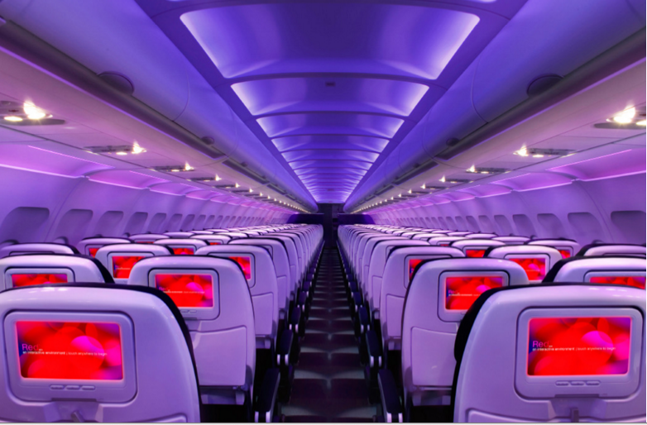

Main Cabin Main Cabin Select First Class

(add links to Cabin Class Pages)

Ready. Set. Fly.

Book your Mood-lit Ride to San Jose, CA.

Heading to San Jose for business or vacation? Consider flying in style to SFO with Virgin America and taking a short drive to San Jose. With Virgin America, you’re guaranteed a first-class flying experience that’s unlike any other. From our mood lighting to on-demand WiFi, you’ll enjoy the journey along with the destination. Join us for your next trip and see for yourself how wonderful it is to fly with us.

Take a Virtual Tour

Add Terms & Conditions